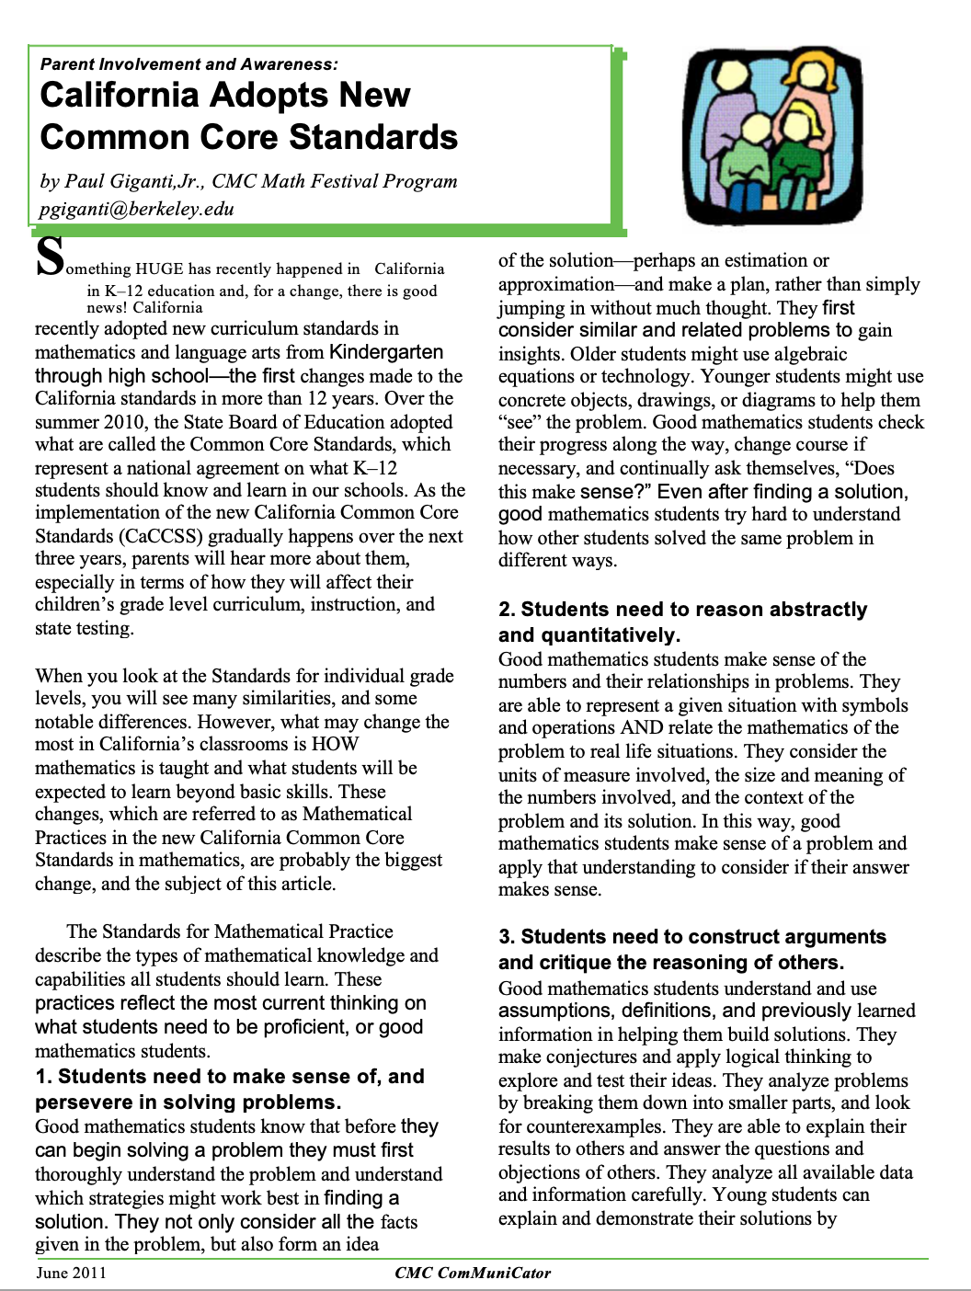

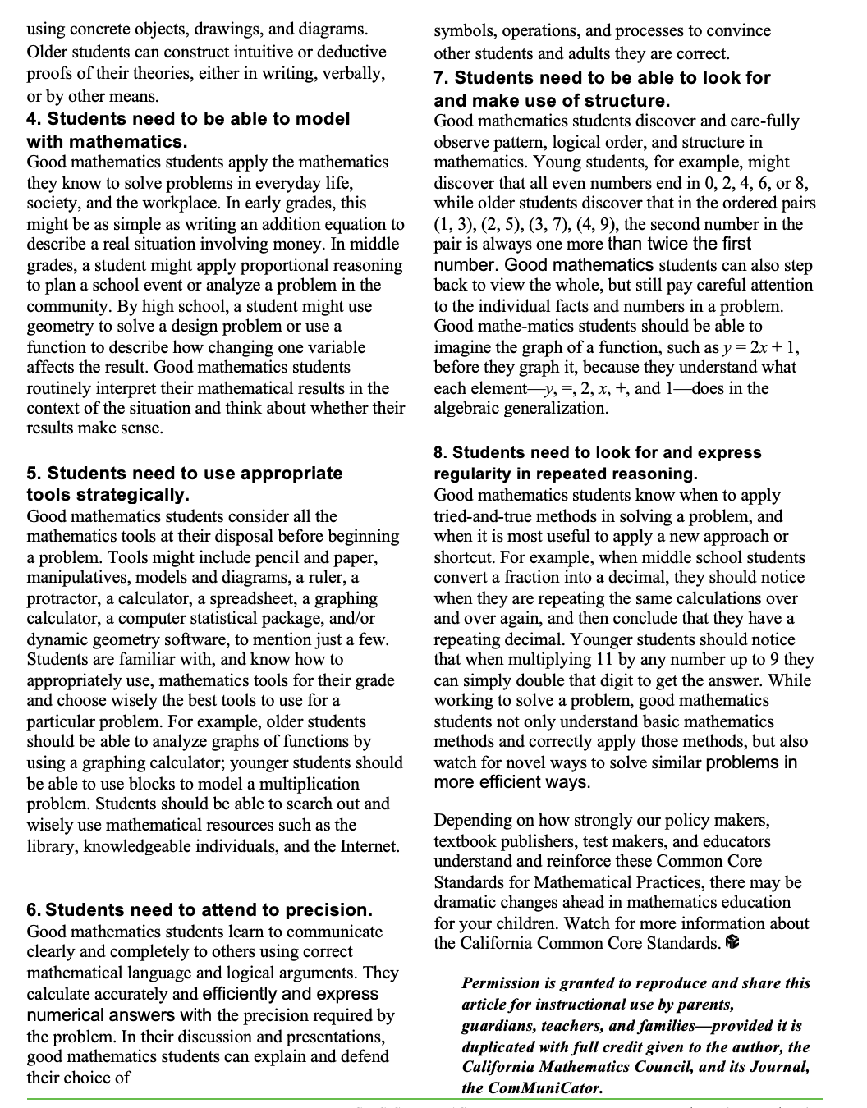

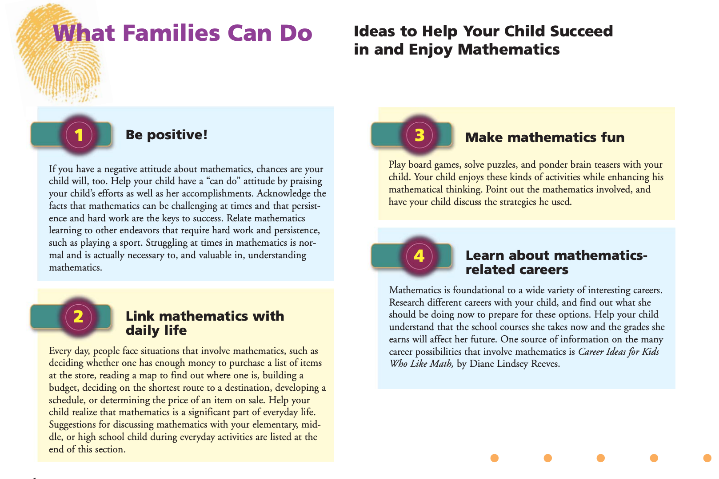

**PICKING THE BEST MATH TOOL**

**Read each problem and choose the best mathematical tool to use on each. Then, in your group, talk about why you chose that tool. Does everyone agree?**



* Estimation
* Mental Math
* Calculator
* Paper and pencil
* Estimation
* Mental Math
* Calculator
* Paper and pencil
* Estimation
* Mental Math
* Calculator
* Paper and pencil
* Estimation
* Mental Math
* Calculator
* Paper and pencil
* Estimation
* Mental Math
* Calculator
* Paper and pencil

5. How much will it cost to put carpet down in this room?

20 feet

Carpet sale: $10/ square foot

10 feet

**Helping with Math Homework**

**Questions to Ask Your Child**

***When your child isn’t sure how to begin a problem, ask:***

* Can you tell me what you know now? What math facts do you have?
* What do you need to find out? Can you estimate the answer?
* How might you begin? What can you try first?
* Can you make a drawing or picture to get started?

***While your child is working on a problem, ask:***

* How can you organize your information? Will a list or table help?
* What would happen if …?
* Show me what you did that didn’t work.
* Can you explain the strategy you’re using to solve this? Why did you …?
* What could you do next?
* Do you see any patterns?

***When your child finds an answer, ask:***

* Does that answer make sense?
* Why do you think that?
* How did you get your answer?
* Why do you think it’s right?
* Convince me that your solution makes sense. Explain it in a different way.

**Resources for Supporting Math at Home**

* Math Play Activities: <https://www.pbs.org/parents/learn-grow/all-ages/math>
* Milestones Math: Videos explaining what students need to know and be able to do in math at each grade level.

<https://www.greatschools.org/gk/category/milestones-subjects/math/>

* Video showing “modern” approaches to learning  addition, subtraction, multiplication, and division (lattice multiplication, for example)

<https://www.youtube.com/watch?v=RlMFj5FOTjU>